Driving Servo Motors (PWM), Or Analog In and Analog Out on the Beaglebone, Along with Wireless Communication

**April 7, 2016**

**Team Members:**

Tatiana Ensslin

Connor Kane

Table of Contents

Introduction 3

Methods 3

Driving a Servo Motor with the Function Generator 3

PWM with the Beaglebone Using the Command Line Interface 3

Driving a Servo Motor with the Beaglebone Using Command Line Interface 3

Driving a Servo Motor with the Beaglebone Using C++ Code 4

Using Analog In to Control a Servo Motor 4

Creating an Ad Hoc Wireless Ring Network 4

Implementing a Custom Protocol on the Ad Hoc Network 5

Results 5

Driving a Servo Motor with the Function Generator 5

PWM with the Beaglebone Using the Command Line Interface 7

Driving a Servo Motor with the Beaglebone Using the Command Line Interface 8

Driving a Servo Motor with the Beaglebone Using C++ Code 9

Using Analog In to Control a Servo Motor 9

Creating an Ad Hoc Wireless Ring Network 9

Implementing a Custom Protocol on the Ad Hoc Network 10

Discussion 10

Appendix A- GPIO with the Beaglebone using the Command Line Interface 11

Appendix B – GPIO with the Beaglebone Using C++ 12

Appendix C – Interfacing a Keypad 19

Appendix D – Reaction Game 22

# Introduction

This lab report presents an application of the Beaglebone Black using a Servo motor, an ESP01 WiFi Module, as well as using a mini USB to connect to the GUI XLaunch. This allows us to see a visual of what we are programming on the Beaglebone through the command line interface. This experiment will focus on driving the Servo motor using PWM, implementing analog in and out on the Beaglebone, as well as creating and utilizing a wireless Ad Hoc Ring network to communication to other groups. This application begins by driving a Servo motor with the function generator to test its frequency, using the PWM with the Beaglebone through the command line, driving the Servo motor with the Beaglebone using the command line and then C++, using analog in to control the Servo motor, and then transitions that knowledge into creating an Ad Hoc Wireless Ring network, and implementing a custom protocol on the network. By the end of the experiment, one will be able to understand how to utilize a PWM on the Beaglebone with a Servo Motor, as well as be able to implement analog signals and a Ad Hoc Wireless Ring network. One will also become familiar with the GUI Xlaunch, and utilize RealTerm. All code can be seen in the Appendix.

# Methods

## Driving a Servo Motor with the Function Generator

For this section, we begin by testing how a servo motor works. Use the function generator to produce the proper control signal for the servo. The servo motor has 3 wires connecting to it: ground (black), power (red), and control (yellow). Almost all servos use 5V to power it. Provide 5V from the Agilent supple on your workbench and control the servo, testing it using the function generator. Use the “pulse” waveform setting on the function generator. Set the voltage between 0-5V, the frequency around 50Hz-400Hz, and vary the duty cycle. Observe how the servo motor works on the different settings and choose a working frequency and determine the duty cycle for setting the “arm” to 0 degrees as well as the duty cycle for setting the “arm” to 180 degrees. Ensure that you are capable of demonstrating that you can control the servo.

## PWM with the Beaglebone Using the Command Line Interface

Next, be sure that you understand how to make the PWM work before you connect the Beaglebone to the servo motor. This is crucial! Use the command line interface to generate the PWM signal at the correct frequency and duty cycle for 0 degrees to 180 degrees. Observe the PWM signal on the logic analyzer or Waveforms and ensure that you are capable of switching between two different duty cycles. Using device tree overlay on the Beaglebone, complete the following commands to set up the PWM: cd $DTOS ; echo am33_xx_pwm driver ; Select the PWM number you choose to use , and then use file control to cat/echo the duty using the knowledge that your period is a specific number. Be sure you can visual the square waves properly outputting the correct duty cycle.

## Driving a Servo Motor with the Beaglebone Using Command Line Interface

Next in the experiment, be careful to not damage the Beaglebone. Connect it to the servo motor but remember that the Beaglebone expects 3.3V, not 5V like the servo. Because of this, the Beaglebone is not powerful enough to drive the servo. This can be solved using an amplifier circuit called a driver. Create this amplifier circuit using a CMOS inverter chip, the CD4069 will do. If you connect two inveters in series, it will not invert, but instead it will be a buffer amplifier. Power the CD4069 from the 5V source, which will make the output of the buffer go from 0V-5V. This is true even for the Beaglebone’s PWM signal. Implement the buffer amplifier to drive the servo motor with the Beaglebone’s PWM, proving that you can move the servo motor from 0 degrees to 180 degrees with the command line while the buffer amplifier is connected.

## Driving a Servo Motor with the Beaglebone Using C++ Code

For this section of the experiment, write a PWM class in C++ on the Beaglebone. Write a test program that uses that class to move the “arm” on the servo motor from 0 degrees to 45 degrees, wait one second, move the “arm” to 90 degrees, wait one second, 135 degrees, wait one second, 135 degrees, wait one second, 180 degrees, wait one second, and then move back to 0 degrees. Given a skeleton PWM class, implement the period, duty, run and polarity getters/setters, and use a sequence of function calls to properly implement and demonstrate this section.

## Using Analog In to Control a Servo Motor

In this part of the experiment, we use the knowledge form last experiment in which we learned how to connect a potentiometer to the Beaglebone and read its position to use the potentiometer to control the angle that the servo motor’s “arm” is set to. As you turn the potentiometer, the servo’s “arm” should move. To complete this, start by using device tree overlay to echo into $SLOTS and cat the analog input which leads to the pin, which is connected to the signal pin on the potentiometer. Then modify the class files to read in the position and compile the code with the G++ _d NAME –std=C++11 FILENAME command. Test the file I/O to ensure its properly working. Ensure you have the properly ASCII conversion. After debugging, merge and create code from the PWM.cpp to the ADC.cpp. Ensure that when you compile you include both files in the command. Be sure to convert your value from the voltage to your PWM cycle so that your servo motor turns accurately.

## Creating an Ad Hoc Wireless Ring Network

This section requires working with other students in your team to each create and Ad Hoc wireless network. WiFi adapters could be used by being placed at the Beaglebone’s USB port for wireless connectivity, however we will use the ESP-01 on the Beaglebone’s UART and send it AT commands to join the network. These will be implemented at the final part of the experiment. Instead, we will use RealTerm and/or PuTTy connected to the ESP-01 to create the network. Start by creating the network by getting the IP address of your Beaglebone and the IP of the group to your right. Open a socket to the IP address of your group to your right and ensure that you are able to send a message through to them. TO do this, use the following AT commands:

AT+CIPMUX = 1

AT+CIPSTA? //gets IP address

AT+CWMODE=3

AT+CIPSERVER=1,port number //create server

AT+CIPSTO=7200 //set server timeout

AT+CIPSTART=1,”TCP”,”IP number”, port number //create socket

AT+CIPSEND = 1, # of chars //send message information

## Implementing a Custom Protocol on the Ad Hoc Network

The final goal of this experiment is to control all of one team’s servo motors from one group’s potentiometer. As one group turns their potentiometer, all servos move in unison to the exact same angle, in REALTIME. This means that the Beaglebones must be running a C++ program which must run without stopping to type anything into the terminal windows. The group controlling the servos will be defined as the “master.” Messages must be passed around the ring using a group created and defined protocol. Its important to note that the Beaglebone is set to echo mode, which can be disabled in the UART.cpp, line 50 options.c_Lflag = 0. Modify your existing code to send the AT commands over C++ in order to communicate properly between the Beaglebone and the ESP device.

# Results

## Driving a Servo Motor with the Function Generator

This section will focus on Output Compare Mode—also know as wasting an exact amount of time. This may be used to connect the Timer Unit Hardware directly to an I/O pin. On the HCS12, the I/O Port T can control the timer. The timer can also be implemented apart from I/O. There are two registers in the Timer Hardware Unit. They are the timer counter resiter (TCNT) and the output compare registers (TCx). There are 8 output compare registers (TC0-TC7), meaning 8 timers can be implemented at a time. When TCNT equals TCx, a flag is set. The steps we used in implementing the timer is as follows:

* Set up the timer by writing to the timer control registers at the beginning of the program.
* Read the 16-bit timer counter register TCNT and add a delay.
* Place the result into the output compare register TCx.
* As an example: TC2 = TCNT + 0x3A58, which configured a delay of 14,936 timer counts on timer 2.
* Wait for the flag to be set. While(!TFLG1_C2F).
* Take note that when creating a repeating delay, the delay should be added to the output compare register. TC2=TC2+ 0x3A58. This will eliminate any timing errors that will be associated with overhead due to software delays.

We configured the timer to create a square wave in 26Hz. First, we set the I/O pin to enable the data direction and then we configured the timer to automatically flip the I/O pin using the toggle option. The frequency will be verified via the oscilliscope. To find the delay in time for the 26Hz:

6x106 / 128 = 46875Hz 46875Hz/26Hz = 1802.9 1802.9/2 = 0x386 (note: 128 is prescale: 111)

SPEEDUP-Note that because its software, when the program is halted, the square wave should stop entirely. In comparison to hardware, where the wave will continue slowed down.

To speed up to 100kHz:

6x106 / 100kHz = 60 60/2=30 with no prescale. This correlates to about 9.96 micro seconds.

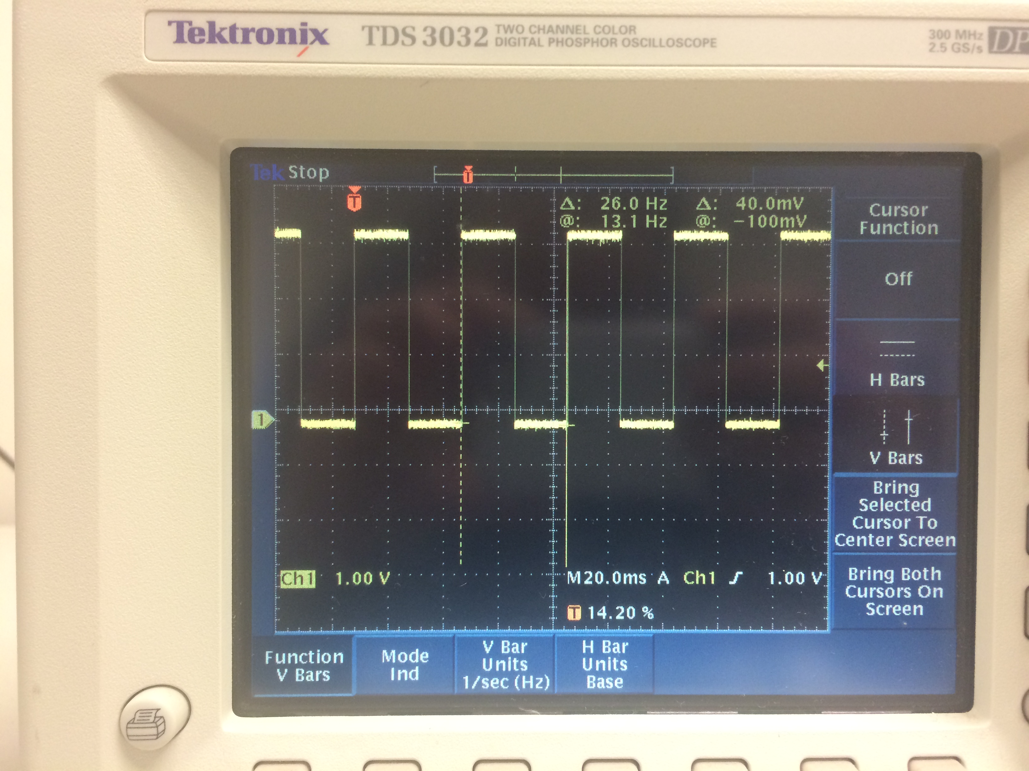

To the left is the software created square wave going at 26Hz.

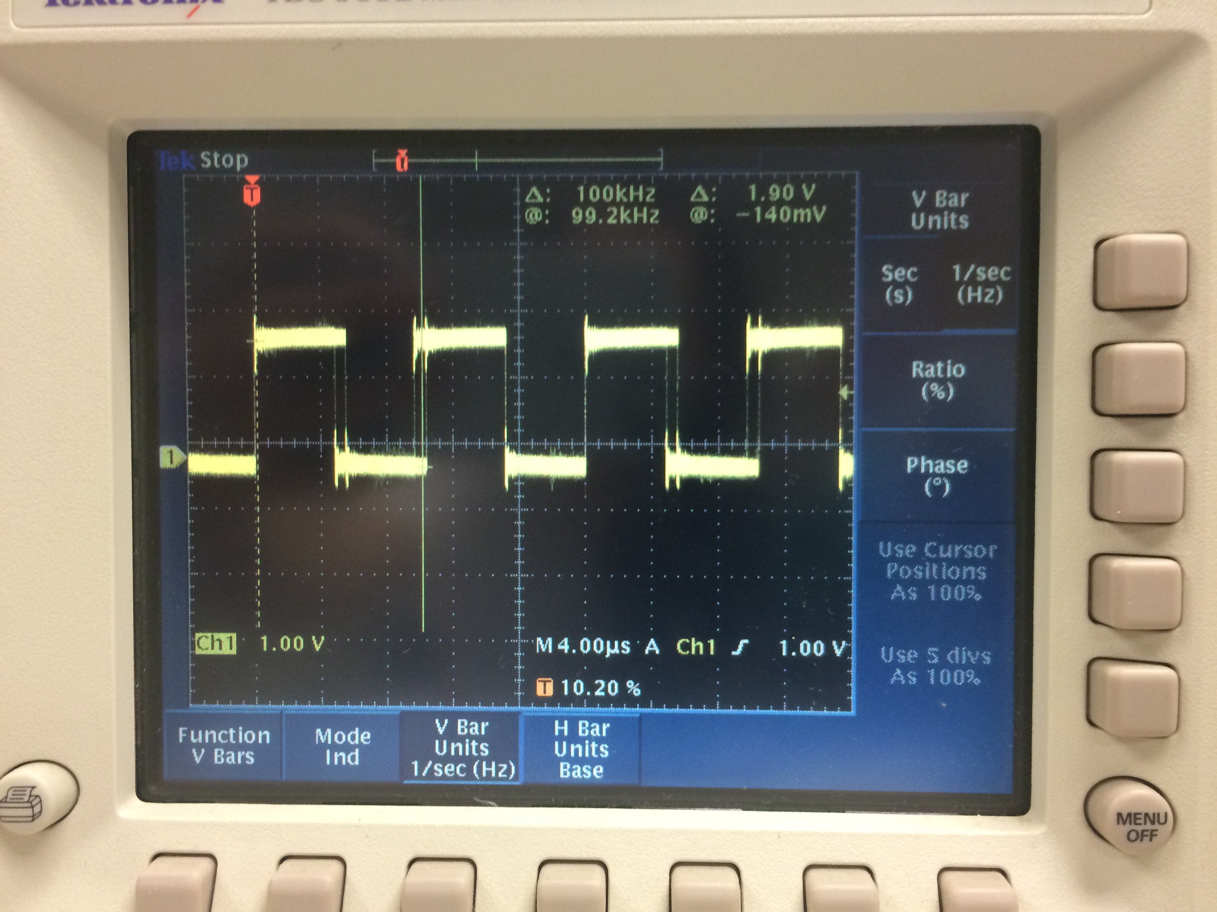

To the right is the software created square wave going at a speed of 100kHz. Note the jitter on the wave.

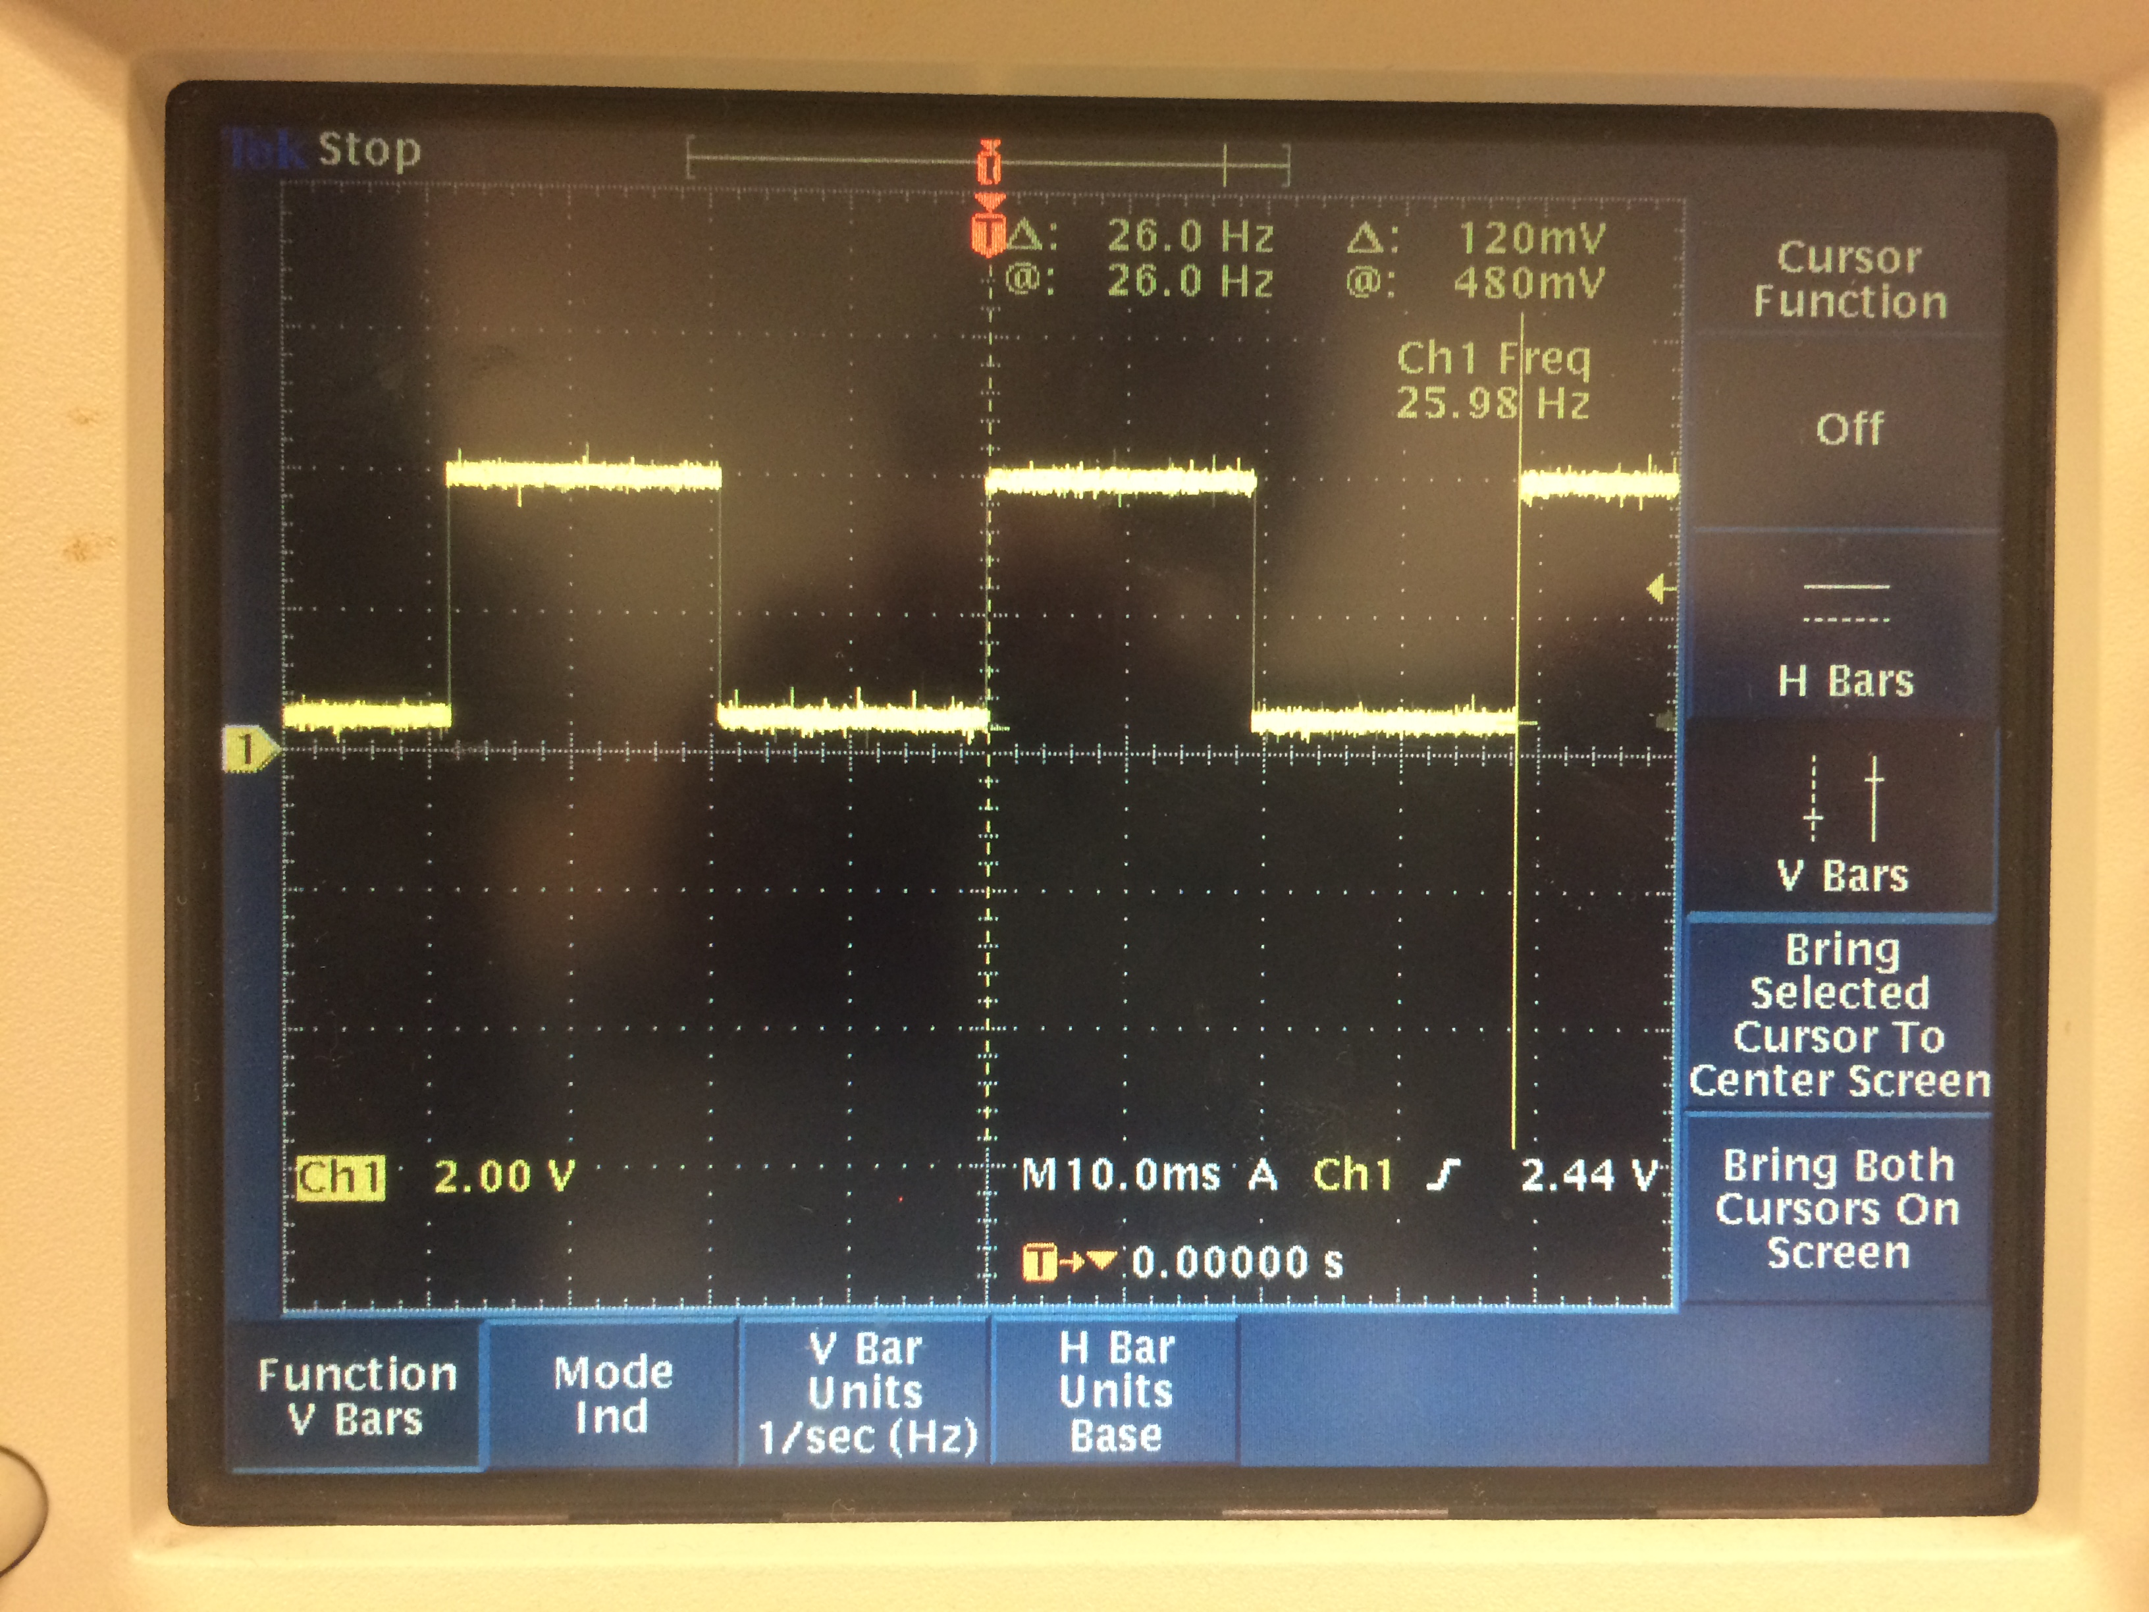

To the left is the 26Hz square wave created through the hardware

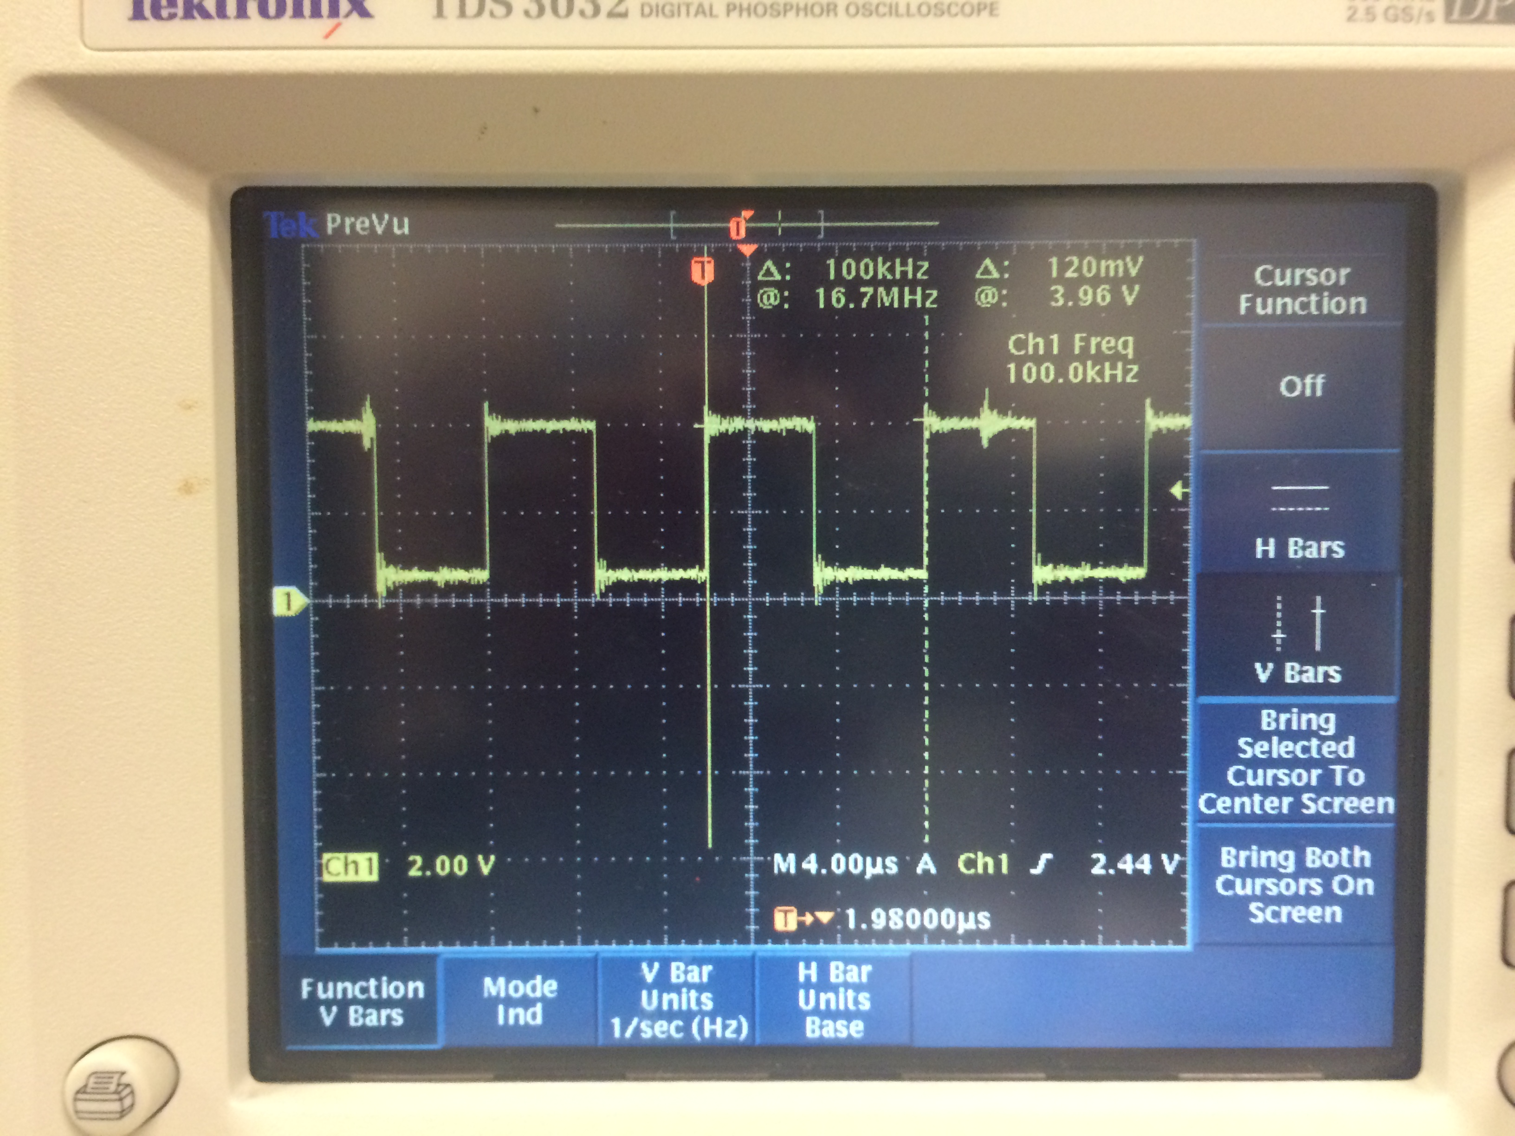To the rigth is the 100kHz square wave created by the hardware. Note the jitter on the wave.

Note the jitter which can be seen on the faster 100kHz square waves. Also, it is important to mention that we had to set the prescaler to divide by 128 for our delay time to accurately slow down the frequency on the 26Hz . The prescaler was removed for the 100kHz frequency. The code for this section can be found in the appendix.

## PWM with the Beaglebone Using the Command Line Interface

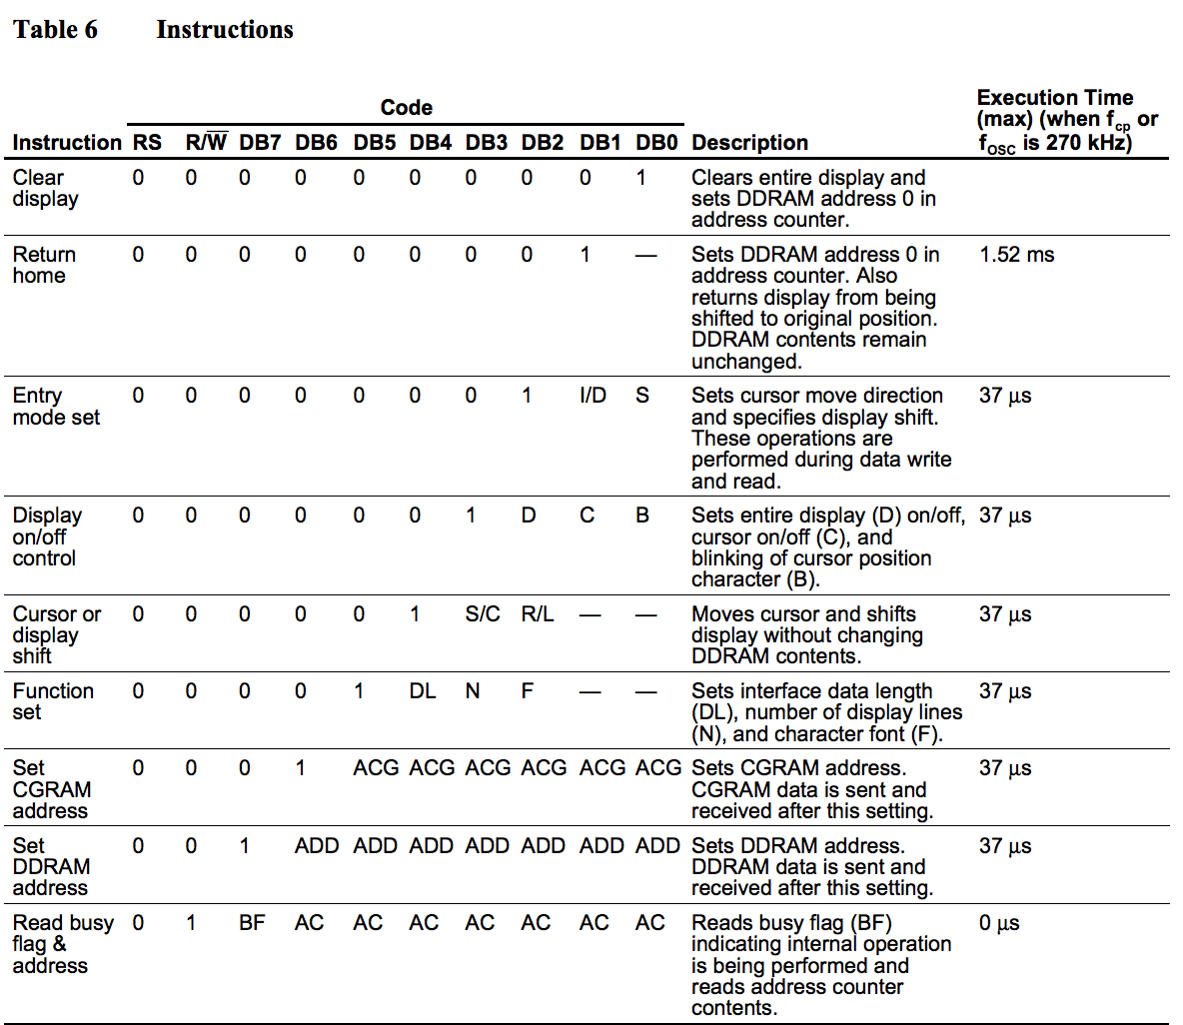 The LCD is located on the Altera DE2 board. We will create a small VHDL circuit that simple connects the LCD pins to the 40-pin header. This will allow us to control the LCD using the HCS12 microcontroller. Using interfacing information about the LCD, we will write a small piece of software that will display “Hello World” on the LCD. In order to make sure we can format the LCD screen, we will display Hello World left justified, along with showing Tatiana and GX centered on the second line. We set two P Ports and 8 AD ports for this section. We will use the timer and set it to 90 for a 49 microsecond delay, and 300 for a 1.65ms delay. This means we need to keep the prescale set to all 0’s. There are two outputs we will be coding on the Altera in VHDL, the LCD_ON and LCD_RW. Table 6 (seen right) on the LCD microcontroller’s data sheet contains the list of signals that can be used to send instructions to the LCD. We will use its 8-bit mode. The process of sending our data to the LCD is as follows: Connect power. Set function set (tells what bits to set). Display on control (set to enable). Set entry mode to 8-bits. Write data in ASCII. Set DDR address (this shifts the cursor to the second line at address 0x064 (if set to that address)). We use VHDL code with 11 inputs and 11 outputs. This will allow us to connect the 40-pin header to our LCD display. To center the 40-Pin header to out LCD display we sent the function set, display control, entry mode set, writing “Hello World”, then setting the DDR address instruction. We used 0xC4 to center our names (position) them on the second line. Our finished result can be viewed below. The code for this section can be found in the appendix.

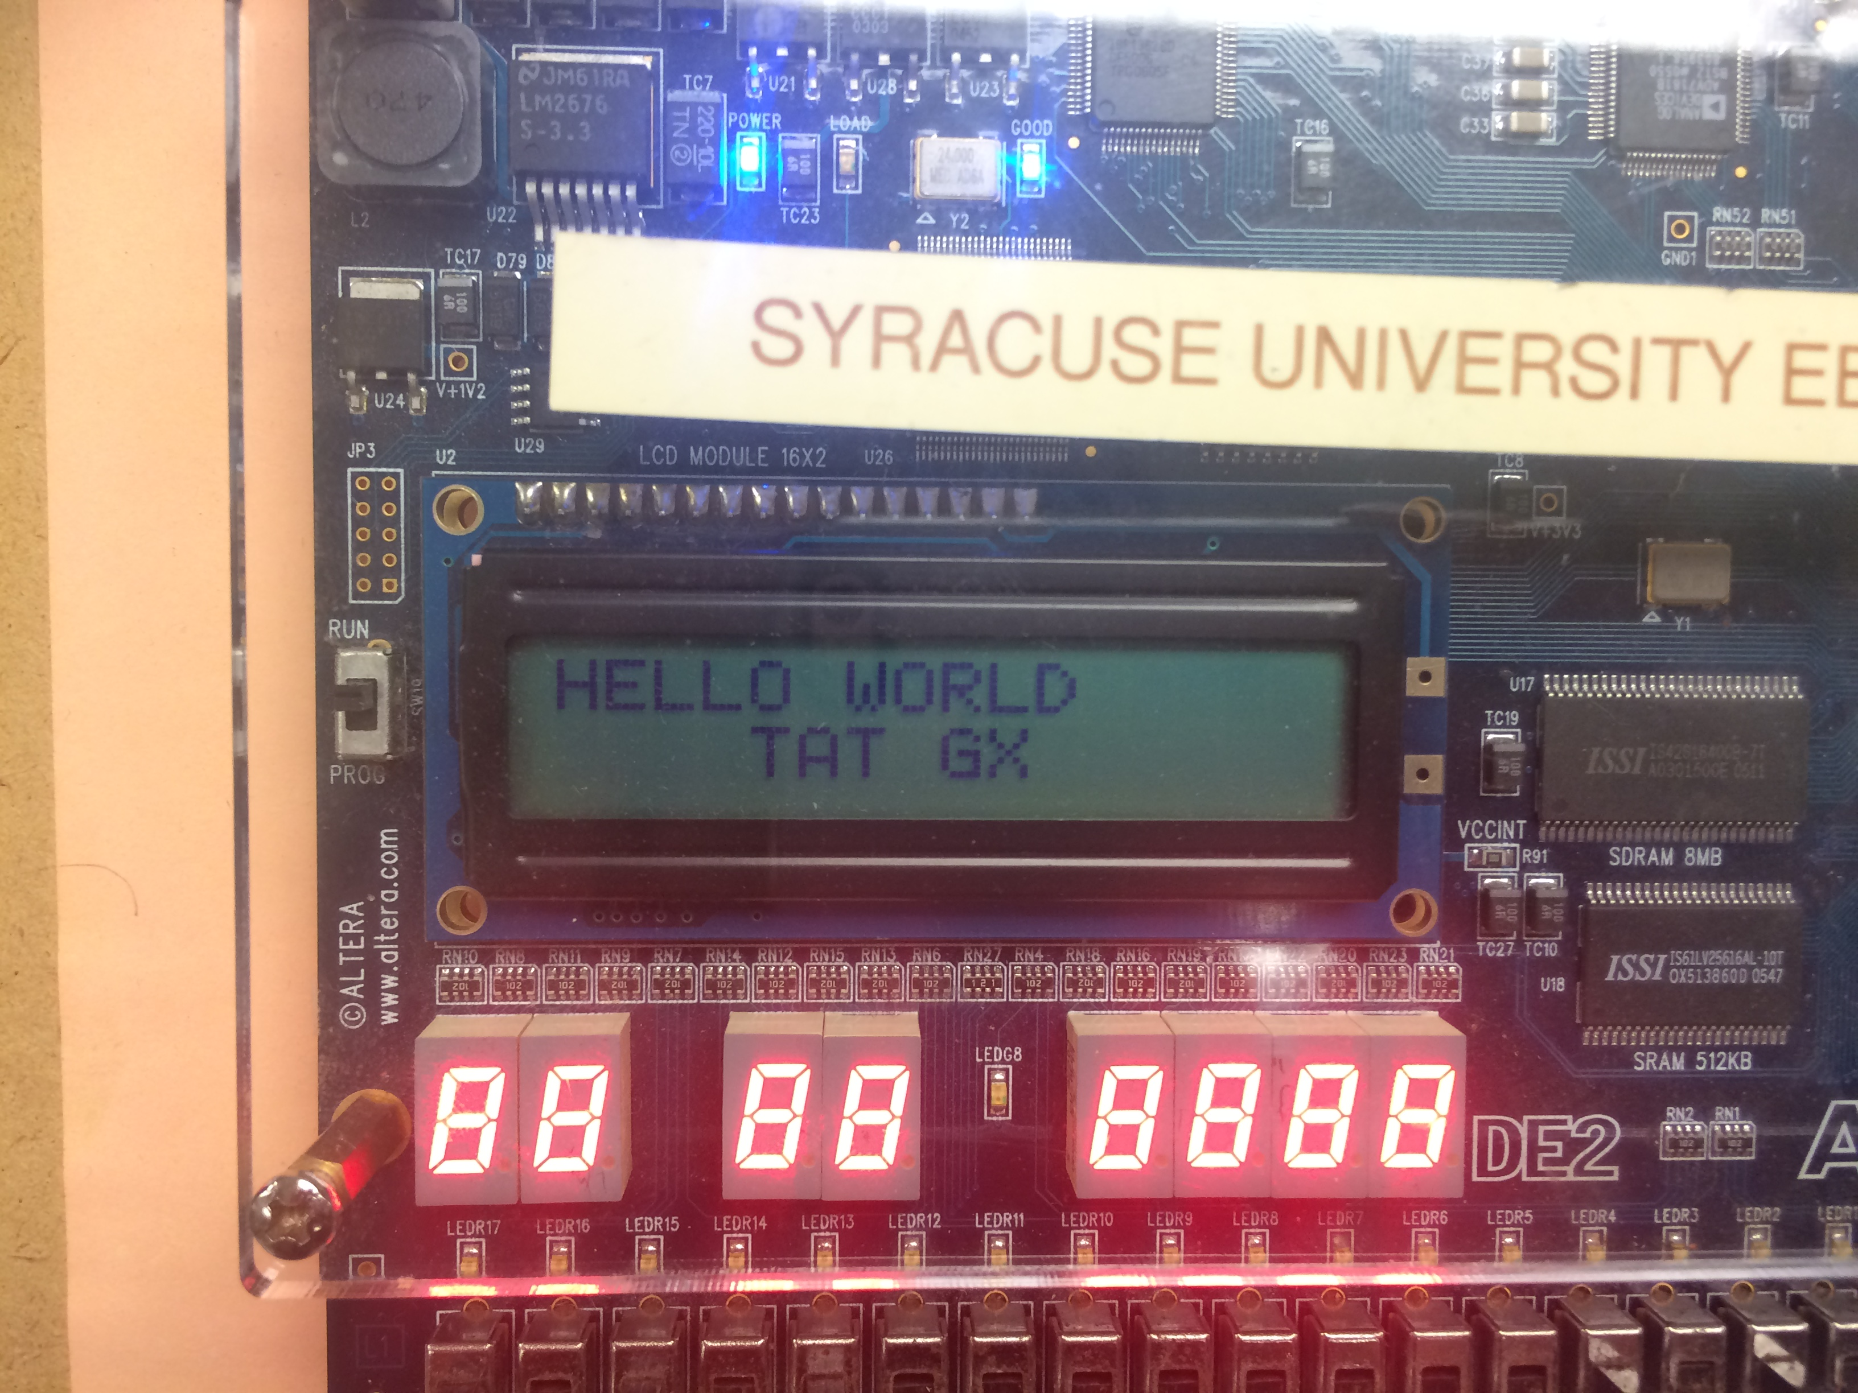

## Driving a Servo Motor with the Beaglebone Using the Command Line Interface

We were given a 4x4 keypad, which is simply 16 switches connected by 8 wires. We will create an algorithm that will implement knowing the pressed button and display it to the LCD. The back of the keypad looks like:

We will have four inputs and four outputs. We will also set a pull enable and polarity register on our ports in order for all the ports to be initialized to ‘0’. Our algorithm will register a ‘1==1,’ which will then print that selected character. We will use an 8-pin header to connect the keypad to our controller. To do this, we set OCPD (enable T ports for non-timer use) to 0xFF and use the T ports to connect the keypad. We will set our rows as out and our columns as in. T0-T3

1 2 3 A

4 5 6 B

7 8 9 C

* 0 # D

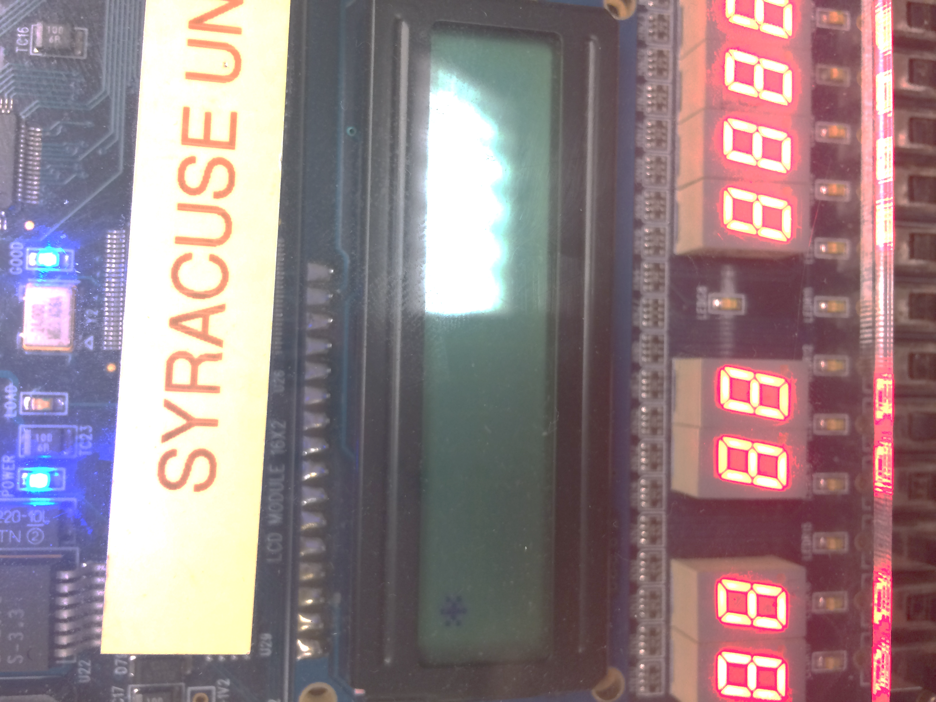are outputs and T4-T7 are our inputs. We now enable the pull registers, which will set all the T ports to ‘0.’ We also created multiple functions to clean and ease the code, such as an enable function which sets the enable bit to ‘1’ then ‘0,’ a cleardisplay function, as well as a writedata function which intakes a character to be printed out. These functions and others include a special delay calculated for the keypad between buttons. Our VHDL code remained the same from the last part. Note that in our code, we clear the LCD screen before changing to the next character. When using the keypad, the wires can have bounce, which is due to the 8 wires crossing unintentionally when a button is pressed. This can be resolved through a small delay, which allows for the full ‘1’ of the button press to be registered. The code for this section can be found in the appendix.

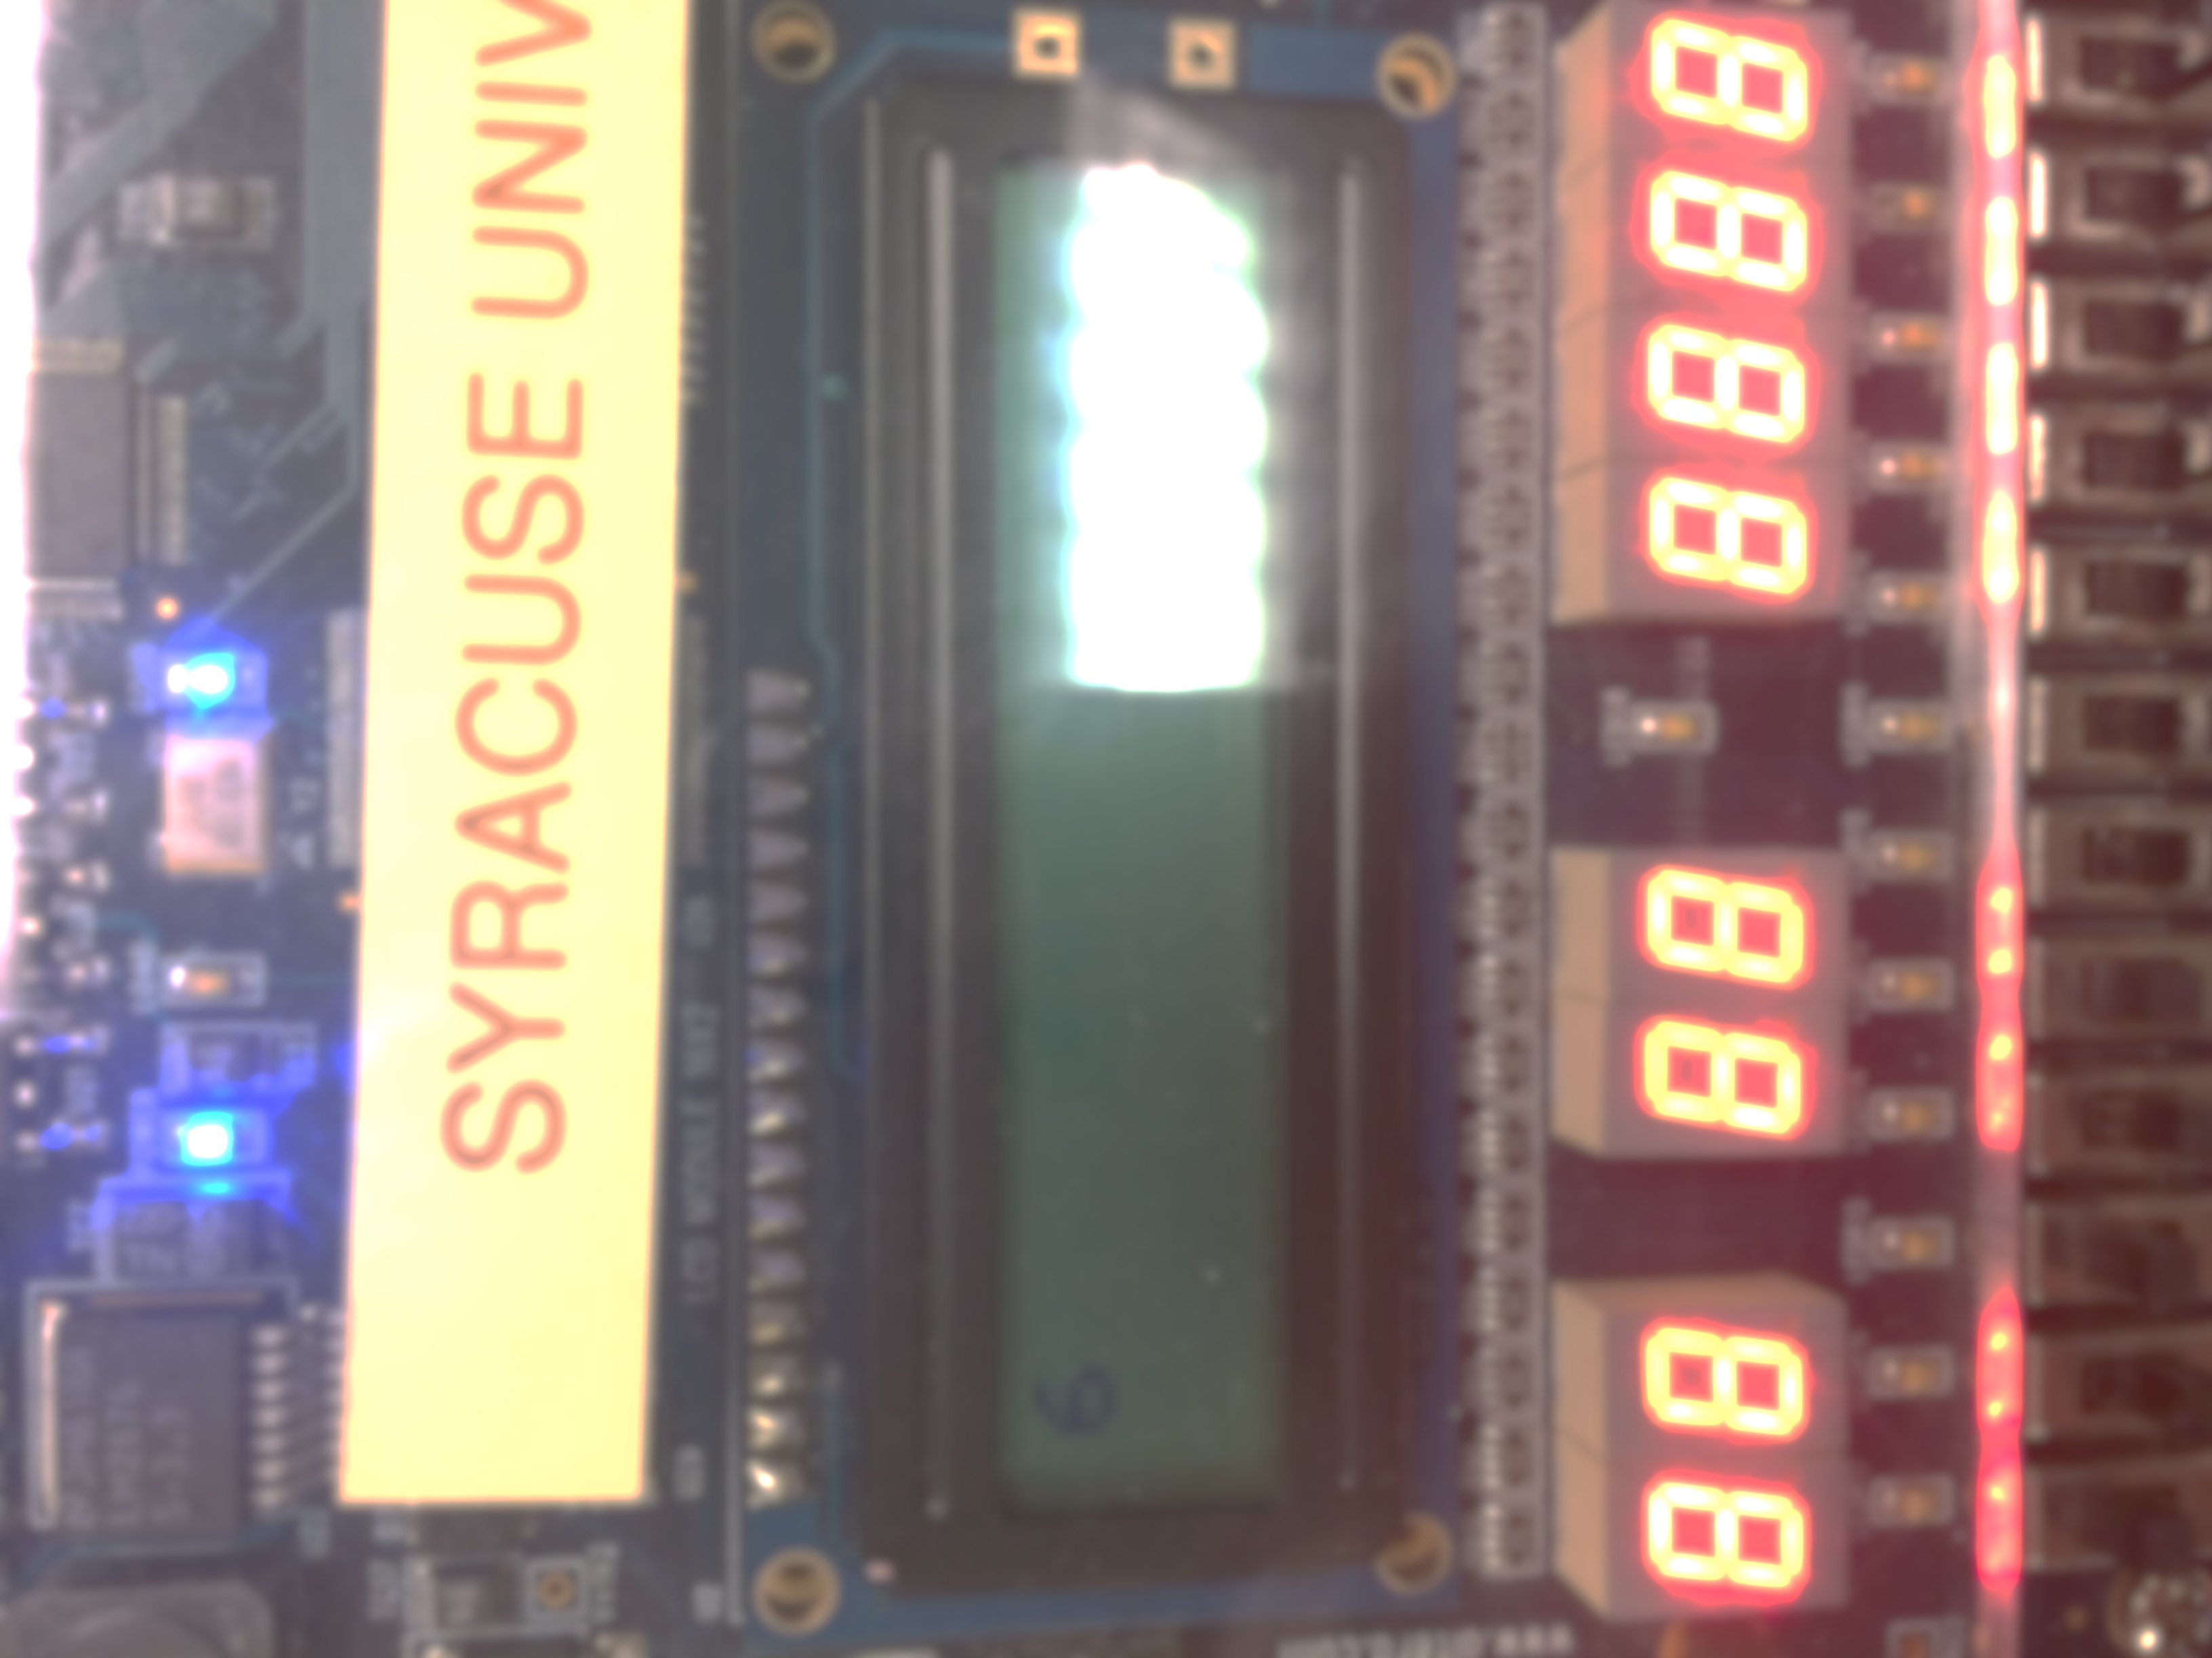

To the left are screenshots of two of the characters being displayed properly on the LCD display after being pressed on the keypad.

## Driving a Servo Motor with the Beaglebone Using C++ Code

For this section, leave the keypad and Altera board connected to the microcontroller. Start by programming on CodeWarrior a piece of software that will begin the game by showing “Press any key to begin” on the LCD. When a key on the keypad is pressed, the program should clear the screen and then display two of the 16-keypad buttons randomly on the first line of the LCD. The user should then press the two keys. The objective is to be able to see how ling it will take to press the two keys. This is not an Input Capture problem; timing resolution on the sub-microsecond scale is not necessary. Once the user has pressed the two keys in the proper order, the program should be able to display the time between the last character displayed on the LCD and the last character pressed on the keypad. The time should then be properly displayed the second line of the LCD to the nearest millisecond. The second line should be formatted to display “Reaction: xxx ms.” The game should then restart after a short 5 to 10 second delay.

## Using Analog In to Control a Servo Motor

For this section, leave the keypad and Altera board connected to the microcontroller. Start by programming on CodeWarrior a piece of software that will begin the game by showing “Press any key to begin” on the LCD. When a key on the keypad is pressed, the program should clear the screen and then display two of the 16-keypad buttons randomly on the first line of the LCD. The user should then press the two keys. The objective is to be able to see how ling it will take to press the two keys. This is not an Input Capture problem; timing resolution on the sub-microsecond scale is not necessary. Once the user has pressed the two keys in the proper order, the program should be able to display the time between the last character displayed on the LCD and the last character pressed on the keypad. The time should then be properly displayed the second line of the LCD to the nearest millisecond. The second line should be formatted to display “Reaction: xxx ms.” The game should then restart after a short 5 to 10 second delay.

## Creating an Ad Hoc Wireless Ring Network

For this section, leave the keypad and Altera board connected to the microcontroller. Start by programming on CodeWarrior a piece of software that will begin the game by showing “Press any key to begin” on the LCD. When a key on the keypad is pressed, the program should clear the screen and then display two of the 16-keypad buttons randomly on the first line of the LCD. The user should then press the two keys. The objective is to be able to see how ling it will take to press the two keys. This is not an Input Capture problem; timing resolution on the sub-microsecond scale is not necessary. Once the user has pressed the two keys in the proper order, the program should be able to display the time between the last character displayed on the LCD and the last character pressed on the keypad. The time should then be properly displayed the second line of the LCD to the nearest millisecond. The second line should be formatted to display “Reaction: xxx ms.” The game should then restart after a short 5 to 10 second delay.

## Implementing a Custom Protocol on the Ad Hoc Network

For this section, leave the keypad and Altera board connected to the microcontroller. Start by programming on CodeWarrior a piece of software that will begin the game by showing “Press any key to begin” on the LCD. When a key on the keypad is pressed, the program should clear the screen and then display two of the 16-keypad buttons randomly on the first line of the LCD. The user should then press the two keys. The objective is to be able to see how ling it will take to press the two keys. This is not an Input Capture problem; timing resolution on the sub-microsecond scale is not necessary. Once the user has pressed the two keys in the proper order, the program should be able to display the time between the last character displayed on the LCD and the last character pressed on the keypad. The time should then be properly displayed the second line of the LCD to the nearest millisecond. The second line should be formatted to display “Reaction: xxx ms.” The game should then restart after a short 5 to 10 second delay.

# Discussion

This lab has provided us with a good understanding of what a microcontroller is capable of doing through its I/O ports as well as with an I/O GPIO expander. This experiment allows one to learn how to use and navigate the GUI XLaunch in coordination with the Beaglebone Black through a mini USB. It allows one to learn the skills and commands necessary to using the command line interface. This lab also does a terrific job of testing one’s ability to use file streaming, as well as object oriented programming. The C++ code, which is implemented throughout this experiment, requires both public and private variables, getters/setters, as well as constructors and destructors. Different class files were created and implemented and certain # declarations were set in place to keep parts of the code (such as the main) safe. It was also interesting to see and note the differences between using the Beaglebone Black with GPIO’s in comparison to programming and implementing GPIO’s through the KL05, which most definitely was a bit easier, requiring only one line of code compared to our C++ class for the Beaglebone. Using a GPIO expander is incredible useful for freeing up the Beaglebone’s original I/O inputs, allowing for the creation and use of multiple other ports to be implementing, including the I2C using the device tree overlay. It is good to note that detecting an analog signal with the Beaglebone can be further implemented into a digital signal using the device tree overlay method. It is also useful that this signal (data) can be handled in multiple ways, such as displaying accurate real-time readouts on an LCD display. The most difficult part of this experiment was creating the GPIO class for the Beaglebone black. This is because we were unfamiliar with the GUI, as well as improperly implementing the requirements through system calls originally—rather than file I/O. Additionally, it was extremely frustrating to debug the code through the G++ debugger once we did have runnable code. Yet, through trial and error, we were eventually able to figure out the cause of our by using the debugging tool and properly run the necessary code.

Although we did encounter a few challenges while working through this lab, such as debugging issues, forgetting to wire a pin to ground, or improperly handling file I/O streaming by opening a file twice unintentionally, we were able to work out our problems. Through use of the datasheet, object files, and knowledge about the communication protocols for the Beaglebone black through GPIO expanders, we were able to successfully complete the experiment.

# Appendix A- GPIO with the Beaglebone using the Command Line Interface

library IEEE;

use IEEE.std_logic_1164.all;

use IEEE.std_logic_unsigned.all;

entity LCD is

port (

t0 : in std_logic;

t1 : in std_logic;

t2 : in std_logic;

t3 : in std_logic;

t4 : in std_logic;

t5 : in std_logic;

t6 : in std_logic;

t7 : in std_logic;

p0 : in std_logic;

outa : out std_logic;

outb : out std_logic;

outc : out std_logic;

outd : out std_logic;

oute : out std_logic;

outf : out std_logic;

outg : out std_logic;

outh : out std_logic;

out1 : out std_logic;

enable : in std_logic;

LCDon : out std_logic;

out2 : out std_logic;

out3 : out std_logic

);

end entity;

architecture behave of LCD is

BEGIN

LCDon <= '1';

out3 <= enable; --P1

out1 <= p0; --RS

out2 <= '0'; --rw

outa <= t0; --hex byte

outb <= t1;

outc <= t2;

outd <= t3;

oute <= t4;

outf <= t5;

outg <= t6;

outh <= t7;

end architecture;

# Appendix B – GPIO with the Beaglebone Using C++

Library IEEE;

use IEEE.std_logic_1164.all;

entity gpio_test is

port

(

gpio_in_led_1 :in std_logic;

gpio_in_led_2 :in std_logic;

gpio_in_led_3 :in std_logic;

gpio_in_led_4 :in std_logic;

gpio_out_led_1 : out std_logic;

gpio_out_led_2 : out std_logic;

gpio_out_led_3 : out std_logic;

gpio_out_led_4 : out std_logic;

gpio_in_switch_1 :in std_logic;

gpio_in_switch_2 :in std_logic;

gpio_in_switch_3 :in std_logic;

gpio_in_switch_4 :in std_logic;

gpio_out_switch_1 : out std_logic;

gpio_out_switch_2 : out std_logic;

gpio_out_switch_3 : out std_logic;

gpio_out_switch_4 : out std_logic

);

end gpio_test;

architecture test of gpio_test is

begin

gpio_out_led_1 <= gpio_in_led_1;

gpio_out_led_2 <= gpio_in_led_2;

gpio_out_led_3 <= gpio_in_led_3;

gpio_out_led_4 <= gpio_in_led_4;

gpio_out_switch_1 <= gpio_in_switch_1;

gpio_out_switch_2 <= gpio_in_switch_2;

gpio_out_switch_3 <= gpio_in_switch_3;

gpio_out_switch_4 <= gpio_in_switch_4;

end test;

GPIO CLASS CODE (.h):

#ifndef BBBCEKGPIO_H

#define BBBCEKGPIO_H

class GPIO{

private:

int value;

int pinNum;

char* direction;

public:

//Constructors

GPIO();

~GPIO();

GPIO(int p, int v, char* d);

void exportPin();

//Setters and getters

int getValue();

int getPin();

char* getDirection();

void setPin(int p);

void setValue(int v);

void setDirection(char* d);

};

#endif

GPIO CLASS CODE (.cpp):

#include "gpio.h"

#include <string>

#include <cstdio>

#include <cstring>

#include <stdlib.h>

#include <iostream>

#include <fstream>

//Default constructor

GPIO::GPIO()

{

value = 0;

direction = new char(0);

pinNum = 0;

}

//Deconstructor

GPIO::~GPIO()

{

std::ofstream myFile;

myFile.open("/sys/class/gpio/unexport");

myFile<<getPin();

myFile.close();

}

//Constructor with arguments that automatically exports and sets values

GPIO::GPIO(int p, int v, char* d)

{

setPin(p);

setDirection(d);

setValue(v);

}

//Writes to the export file the pin number

void

GPIO::exportPin()

{

std::ofstream myFile;

myFile.open("/sys/class/gpio/export");

myFile<<getPin();

myFile.close();

}

int

GPIO::getValue()

{

std::fstream myFile;

char buf[50];

sprintf(buf, "/sys/class/gpio/gpio%d/value",getPin());

myFile.open(buf);

if (myFile.is_open())

{

while ( myFile.eof() == false )

{

myFile >> value;

}

myFile.close();

}

return value;

}

char*

GPIO::getDirection()

{

return direction;

}

int

GPIO::getPin()

{

return pinNum;

}

//Sets p to pinNum and exports the pin by calling the exportPin() func

void

GPIO::setPin(int p)

{

pinNum = p;

exportPin();

}

//Sets value by writing the given v to the value file

void

GPIO::setValue(int v)

{

std::ofstream myFile;

char buf[50];

sprintf(buf, "/sys/class/gpio/gpio%d/value",getPin());

myFile.open(buf);

myFile<<v;

myFile.close();

value = v;

}

//Sets direction by writing either in or out to the direction file

void

GPIO::setDirection(char* d)

{

std::ofstream myFile;

char buf[50];

sprintf(buf, "/sys/class/gpio/gpio%d/direction",getPin());

myFile.open(buf);

myFile<<d;

myFile.close();

direction = new char(strlen(d));

strcpy(direction, d);

}

//Creates two inputs and two output GPIO objects

#ifdef TEST_GPIO

int

main(int argc, char **argv)

{

char* buffer_out= "out";

char* buffer_in= "in";

GPIO pinA(73,0,buffer_out);

GPIO pinB(74,0,buffer_out);

GPIO pinC(69,0,buffer_out);

GPIO pinD(51,0,buffer_out);

GPIO pinE(112,0,buffer_in);

GPIO pinF(110,0,buffer_in);

GPIO pinG(113,0,buffer_in);

GPIO pinH(111,0,buffer_in);

while(1){

pinA.setValue(pinE.getValue());

pinB.setValue(pinF.getValue());

pinC.setValue(pinG.getValue());

pinD.setValue(pinH.getValue());

}

return 0;

}

#endif

#ifdef TEST_DECONSTRUCT

int

main(int argc, char **argv)

{

char* buffer_out= "out";

char* buffer_in= "in";

GPIO pinA(73,0,buffer_out);

GPIO pinB(74,0,buffer_out);

GPIO pinC(69,0,buffer_out);

GPIO pinD(51,0,buffer_out);

GPIO pinE(112,0,buffer_in);

GPIO pinF(110,0,buffer_in);

GPIO pinG(113,0,buffer_in);

GPIO pinH(111,0,buffer_in);

return 0;

}

#endif

# Appendix C – Interfacing a Keypad

#include <hidef.h> /* common defines and macros */

#include "derivative.h" /* derivative-specific definitions */

void enable();

void writeData(unsigned char letter);

void clearDisplay();

void Delay();

void main(void) {

// port initializations

DDR1AD0=0xFF;

DDRM_DDRM2=1;

DDRM_DDRM3=1;

DDRT=0xF0; //set t0-t3 as inputs and t4-t7 as outputs

PERT = 0x0F; //set the pull enable all to 0

PPST = 0x0F; //polarity

OCPD=0xFF; //enable T ports as i/o

//Timer Initializations

TIOS=0xFF;

TCTL2=0x10;

TSCR1_TEN=1;

TSCR1_TFFCA=1;

TSCR2=0x03;

//send beginning instructions

clearDisplay();

while(!TFLG1_C0F){}

TC0=TCNT + 300; //49microsecond delay

//functon set

PT1AD0 = 0x3F;

PTM_PTM3 = 0;

enable();

TC0=TCNT + 300; //49mic delay

while(!TFLG1_C0F){}

//display on

PT1AD0 = 0x0E;PTM_PTM3 = 0;

enable();

TC0=TCNT + 300; //49mic delay

while(!TFLG1_C0F){}

//entry mode

PT1AD0 = 0x06;

PTM_PTM3 = 0;

enable();

TC0=TCNT + 300; //49mic delay

while(!TFLG1_C0F){}

TC0=TCNT + 300; //49mic delay

while(!TFLG1_C0F){}

// end beginning instructions

//=================================================================

//algorithm to recognize letter

int i =0;

for(;;){

for(int i = 0; i <4; i++){

if(i==0){

PTT_PTT4=1;

PTT_PTT5=0;

PTT_PTT6=0;

PTT_PTT7=0;

Delay();

if(PTT_PTT0==1) {

clearDisplay();

writeData(0x44); //1

}

Delay();

if(PTT_PTT1==1) {

clearDisplay();

writeData(0x23); //4

}

Delay();

if(PTT_PTT2==1) {

clearDisplay();

writeData(0x30); //7

}

Delay();

if(PTT_PTT3==1) {

clearDisplay();

writeData(0x2A); //x

}

Delay();

}

if(i==1){

PTT_PTT4=0;

PTT_PTT5=1;

PTT_PTT6=0;

PTT_PTT7=0;

if(PTT_PTT0==1) {

clearDisplay();

writeData(0x43);//send 2

}

if(PTT_PTT1==1) {

clearDisplay();

writeData(0x39);//send5

}

if(PTT_PTT2==1) {

clearDisplay();

writeData(0x38);//send8

}

if(PTT_PTT3==1) {

clearDisplay();

writeData(0x37); //send 0

}

}

if(i==2){

PTT_PTT4=0;

PTT_PTT5=0;

PTT_PTT6=1;

PTT_PTT7=0;

if(PTT_PTT0==1) {

clearDisplay();

writeData(0x42);//send 3

}

if(PTT_PTT1==1) {

clearDisplay();

writeData(0x36); //send6

}

if(PTT_PTT2==1) {

clearDisplay();

writeData(0x35);//send9

}

if(PTT_PTT3==1) {

clearDisplay();

writeData(0x34);//send #

}

}

if(i==3){

PTT_PTT4=0;

PTT_PTT5=0;

PTT_PTT6=0;

PTT_PTT7=1;

Delay();

if(PTT_PTT0==1) {

clearDisplay();

writeData(0x41);//send A

}

Delay();

if(PTT_PTT1==1) {

clearDisplay();

writeData(0x33);//sendB

}

if(PTT_PTT2==1) {

clearDisplay();

writeData(0x32);//sendC

}

if(PTT_PTT3==1) {

clearDisplay();

writeData(0x31);//send D

}

}

}

}

}

void clearDisplay(){

TC0=TCNT + 300; //49mic delay

while(!TFLG1_C0F){}

//clear screen

PT1AD0=0X01;//CLEAR DISPLAY

PTM_PTM3=0; // RS

PTM_PTM2=1; // SELECT DATA

PTM_PTM2=0;

}

void enable(){

PTM_PTM2 = 1; //this is the enable for the LCD

PTM_PTM2 = 0; //this is the enable for the LCD

}

void writeData(unsigned char letter){

TSCR2_PR0=0;

TSCR2_PR1=1;

TSCR2_PR2=0;

TC0=TCNT + 6760; //49mic delay

while(!TFLG1_C0F){}

//write data

PTM_PTM3 = 1;

PT1AD0 = letter;

enable();

}

void Delay(){

TSCR2_PR0=0;

TSCR2_PR1=1;

TSCR2_PR2=1;

TC0=TCNT + 0x2497; //delay

while(!TFLG1_C0F){}

}

# Appendix D – Reaction Game

#include <hidef.h> /* common defines and macros */

#include "derivative.h" /* derivative-specific definitions */

void enable();

void writeData(unsigned char letter);

void clearDisplay();

void Delay();

void reposition(unsigned char position); //set DDgram

void writeData2(unsigned char letter);

void run();

void welcome();

void sendInitInstructions();

void generateSecretNumbers();

//void pressAnyButton(); //begins game

void findButton(); //finds and prints when a button is pressed

int num;

int num2;

unsigned char symbols[16]={0x31,0x32,0x33,0x34,0x35,0x36,0x37,0x38,0x39,0x30,0x2A,0x23,0x41,0x42,0x43,0x44};

unsigned char answer1;

unsigned long int time1;

unsigned long int time2;

unsigned long int reactionTime;

unsigned long int a,b,c,d;

void main(void) {

// port initializations

DDR1AD0=0xFF;

DDRM_DDRM2=1;

DDRM_DDRM3=1;

DDRT=0xF0; //set t0-t3 as inputs and t4-t7 as outputs

PERT = 0x0F; //set the pull enable all to 0

PPST = 0x0F; //polarity

OCPD=0xFF; //enable T ports as i/o

//Timer Initializations

TIOS=0xFF;

TCTL2=0x10;

TSCR1_TEN=1;

TSCR1_TFFCA=1;

TSCR2=0x03;

//send beginning instructions

sendInitInstructions();

/* generate secret number between 1 and 10: */

generateSecretNumbers();

//Welcome the player to the game

welcome();

//pressAnyButton();

for (int k; k<5000; k++){

PTT_PTT4=1;

if (PTT_PTT0 == 1 && PTT_PTT4 == 1)

run();

}

//start timer here

time1= TCNT;

findButton();

}

//============================end of main====================================//

void run(){

clearDisplay();

writeData(symbols[num]);

writeData(symbols[num2]);

}

void clearDisplay(){

TC0=TCNT + 300; //49mic delay

while(!TFLG1_C0F){}

//clear screen

PT1AD0=0X01;//CLEAR DISPLAY

PTM_PTM3=0; // RS

PTM_PTM2=1; // SELECT DATA

PTM_PTM2=0;

}

void enable(){

PTM_PTM2 = 1; //this is the enable for the LCD

PTM_PTM2 = 0; //this is the enable for the LCD

}

void writeData(unsigned char letter){

TSCR2_PR0=0;

TSCR2_PR1=1;

TSCR2_PR2=0;

TC0=TCNT + 6760; //49mic delay

while(!TFLG1_C0F){}

//write data

PTM_PTM3 = 1;

PT1AD0 = letter;

enable();

}

void Delay(){

TSCR2_PR0=0;

TSCR2_PR1=1;

TSCR2_PR2=1;

TC0=TCNT + 0x2497; //delay

while(!TFLG1_C0F){}

}

void reposition(unsigned char position){

TSCR2_PR0=0;

TSCR2_PR1=1;

TSCR2_PR2=0;

TC0=TCNT + 6760; //49mic delay

while(!TFLG1_C0F){}

PT1AD0 = position; //set to 1st line far left

PTM_PTM3 = 0;

enable();

}

void writeData2(unsigned char letter){

if(letter == symbols[num]){

answer1 = letter;

return;

}

if(answer1 == symbols[num]){

if (letter == symbols[num2]){

//end counter

time2=TCNT;

reactionTime = time2-time1;

reactionTime = reactionTime * 1000; // convert clock cycles to seconds

reactionTime = reactionTime/46875;

a = reactionTime % 10; // convert number to single byte

reactionTime/=10;

b = reactionTime % 10;

reactionTime/=10;

c = reactionTime % 10;

reactionTime/=10;

d = reactionTime % 10;

reposition(0xC2);

writeData(0x52);//R

writeData(0x65);//e

writeData(0x61);//a

writeData(0x63); //c

writeData(0x74);//t

writeData(0x69);//i

writeData(0x6F);//o

writeData(0x6E);//n

writeData(0x3A);//:

writeData(0x20);// #+0x30 convert to ascii

writeData(d); //send single byte

writeData(c);

writeData(b);

writeData(a);

}

}

}

void welcome(){

writeData(0x50);//P

writeData(0x72);//r

writeData(0x65);//e

writeData(0x73);//s

writeData(0x73);//s

writeData(0x20);//

writeData(0x41);//A

writeData(0x6E);//n

writeData(0x79);//y

writeData(0x20);//

writeData(0x4B);//K

writeData(0x65);//e

writeData(0x79);//y

writeData(0x20);//

writeData(0x54);//T

writeData(0x6F);//o

reposition(0xC6);//next line

writeData(0x42);//B

writeData(0x65);//e

writeData(0x67);//g

writeData(0x69);//i

writeData(0x6E);//n

}

void sendInitInstructions(){

TSCR2=0x03;

clearDisplay();

while(!TFLG1_C0F){}

TC0=TCNT + 300; //49microsecond delay

//functon set

PT1AD0 = 0x3F;

PTM_PTM3 = 0;

enable();

TC0=TCNT + 300; //49mic delay

while(!TFLG1_C0F){}

//display on

PT1AD0 = 0x0E;PTM_PTM3 = 0;

enable();

TC0=TCNT + 300; //49mic delay

while(!TFLG1_C0F){}

//entry mode

PT1AD0 = 0x06;

PTM_PTM3 = 0;

enable();

TC0=TCNT + 300; //49mic delay

while(!TFLG1_C0F){}

TC0=TCNT + 300; //49mic delay

while(!TFLG1_C0F){}

}

void generateSecretNumbers(){

num = TC0 % 16;

while(!TFLG1_C0F){}

TC0=TCNT + 300; //49mic delay

num2 = (TC0 +30) %16;

}

void findButton(){

TSCR2=0x07;

for(;;) {

for(int i = 0; i <4; i++){

PTT_PTT4=0;

PTT_PTT5=0;

PTT_PTT6=0;

PTT_PTT7=0;

if(i==0){

PTT_PTT4=1;

Delay();

if(PTT_PTT0==1) {

writeData2(0x44);

}

Delay();

if(PTT_PTT1==1) {

writeData2(0x23);

}

Delay();

if(PTT_PTT2==1) {

writeData2(0x30);

}

Delay();

if(PTT_PTT3==1) {

writeData2(0x2A);

}

Delay();

}

if(i==1){

PTT_PTT5=1;

if(PTT_PTT0==1) {

writeData2(0x43);

}

if(PTT_PTT1==1) {

writeData2(0x39);

}

if(PTT_PTT2==1) {

writeData2(0x38);

}

if(PTT_PTT3==1) {

writeData2(0x37);

}

}

if(i==2){

PTT_PTT6=1;

if(PTT_PTT0==1) {

writeData2(0x42);

}

if(PTT_PTT1==1) {

writeData2(0x36);

}

if(PTT_PTT2==1) {

writeData2(0x35);

}

if(PTT_PTT3==1) {

writeData2(0x34);

}

}

if(i==3){

PTT_PTT7=1;

Delay();

if(PTT_PTT0==1) {

writeData2(0x41);

}

Delay();

if(PTT_PTT1==1) {

writeData2(0x33);

}

if(PTT_PTT2==1) {

writeData2(0x32);

}

if(PTT_PTT3==1) {

writeData2(0x31);

}

}

}

}

}